## Task 01: Create Ad Hoc SQL FIRST_VALUE, LAST_VALUE

SELECT month

, brand

, TO_CHAR ( profit

, '$99,999,999,999' )

AS profit

FROM ( SELECT EXTRACT ( MONTH FROM event_dt ) AS month

, brand

, SUM ( price - cost ) AS profit

, FIRST_VALUE ( SUM ( price - cost ) )

OVER (PARTITION BY EXTRACT ( MONTH FROM event_dt ) ORDER BY SUM ( price - cost ) DESC)

AS max_profit_in_month

, LAST_VALUE (

SUM ( price - cost )

)

OVER ( PARTITION BY EXTRACT ( MONTH FROM event_dt )

ORDER BY SUM ( price - cost ) DESC

ROWS BETWEEN UNBOUNDED PRECEDING AND UNBOUNDED FOLLOWING )

AS min_profit_in_month

FROM contracts

WHERE cost < price

AND customer_country LIKE 'Belarus'

AND EXTRACT ( YEAR FROM event_dt ) = :year

GROUP BY EXTRACT ( MONTH FROM event_dt )

, brand)

WHERE profit = max_profit_in_month

OR profit = min_profit_in_month

ORDER BY month

, profit DESC;

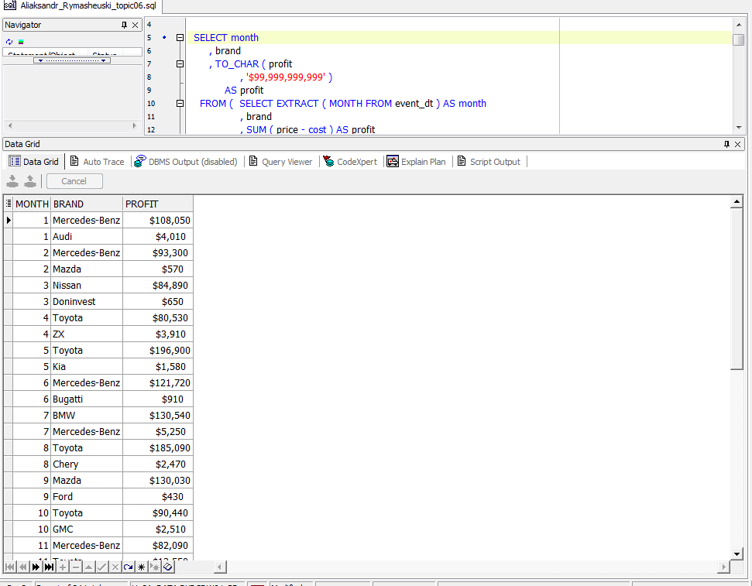

## Task 02: Create Ad Hoc SQL RANK, DENSE_RANK, ROWNUM

SELECT DECODE ( rn, 1, "Year", '' ) AS "Year"

, rn AS "N/N"

, brand

, quantity_sold

FROM ( SELECT EXTRACT ( YEAR FROM event_dt ) AS "Year"

, brand

, COUNT ( brand ) AS quantity_sold

, ROW_NUMBER ( ) OVER (PARTITION BY EXTRACT ( YEAR FROM event_dt ) ORDER BY COUNT ( brand ) DESC) AS rn

FROM contracts

WHERE customer_city LIKE 'Minsk'

GROUP BY EXTRACT ( YEAR FROM event_dt )

, brand)

WHERE rn < 6;

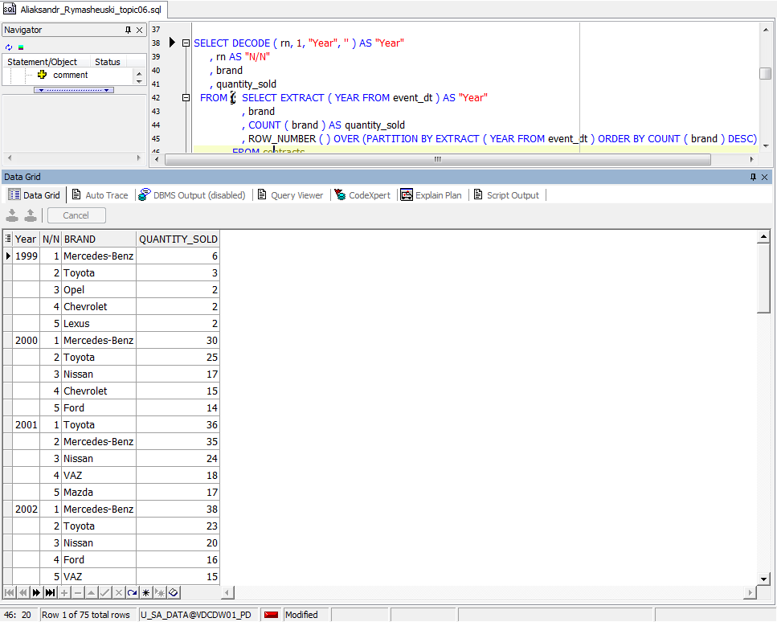

SELECT DECODE ( "Rank", 1, "Year", '' ) AS "Year"

, brand

, TO_CHAR ( profit

, '$99,999,999,999' )

AS profit

FROM ( SELECT EXTRACT ( YEAR FROM event_dt ) AS "Year"

, brand

, SUM ( price - cost ) AS profit

, DENSE_RANK ( ) OVER (PARTITION BY EXTRACT ( YEAR FROM event_dt ) ORDER BY SUM ( price - cost ) DESC)

AS "Rank"

FROM contracts

WHERE customer_city LIKE 'Minsk'

GROUP BY EXTRACT ( YEAR FROM event_dt )

, brand)

WHERE "Rank" < 4;

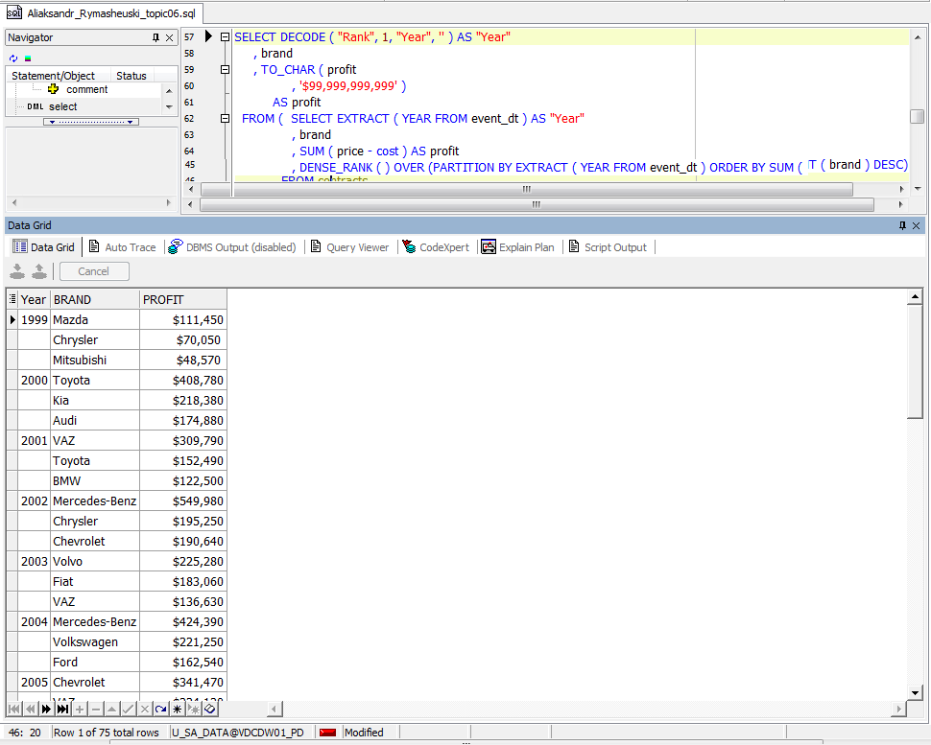

## Task 03: Create Ad Hoc SQL AGGREAGATE FUNCS

SELECT DECODE ( r, 1, month, '' ) AS "Month"

, brand

, TO_CHAR ( profit

, '$99,999,999,999' )

AS profit

, TO_CHAR ( ( profit - max_profit_in_month )

, '$99,999,999,999' )

AS "Profit-MAX profit"

, TO_CHAR ( ( profit - min_profit_in_month )

, '$99,999,999,999' )

AS "Profit-MIN profit"

, TO_CHAR ( ROUND ( profit - avg_profit_in_month )

, '$99,999,999,999' )

AS "Profit-AVG profit"

FROM ( SELECT EXTRACT ( MONTH FROM event_dt ) AS month

, brand

, SUM ( price - cost ) AS profit

, MAX ( SUM ( price - cost ) ) OVER (PARTITION BY EXTRACT ( MONTH FROM event_dt )) AS max_profit_in_month

, MIN ( SUM ( price - cost ) ) OVER (PARTITION BY EXTRACT ( MONTH FROM event_dt )) AS min_profit_in_month

, AVG ( SUM ( price - cost ) ) OVER (PARTITION BY EXTRACT ( MONTH FROM event_dt )) AS avg_profit_in_month

, RANK ( ) OVER (PARTITION BY EXTRACT ( MONTH FROM event_dt ) ORDER BY SUM ( price - cost ) DESC) AS r

FROM contracts

WHERE cost < price

AND customer_country LIKE 'Belarus'

AND EXTRACT ( YEAR FROM event_dt ) = :year

GROUP BY EXTRACT ( MONTH FROM event_dt )

, brand)

WHERE profit - avg_profit_in_month > 0

ORDER BY month

, profit DESC;

